***“ Website Performance Optimization Report ’’***

***NIMRA ADREES***

***CID: DEN10510***

***TASK # 03***

1. ***Introduction***

*Website Name:* ***TravelTribe***

The goal of this task was to analyze and optimize the performance of the TravelTribe website. The site is a travel service platform offering users a way to explore destinations, book travel packages, and read customer reviews. The optimization focuses on improving performance by minimizing HTTP requests, optimizing assets, and using best practices to reduce load times and enhance user experience.

1. ***Initial Analysis***

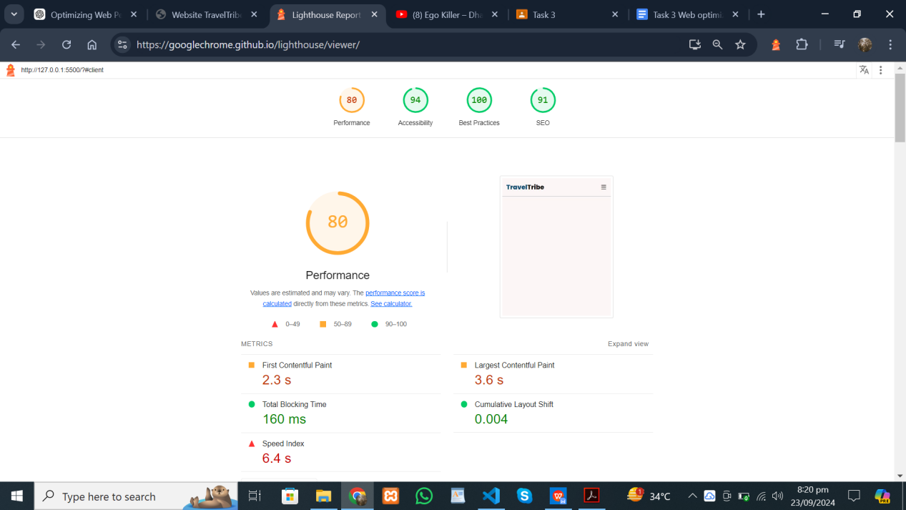

*Key Issues Identified:*

- Large images: Non-optimized images were causing longer load times.

- Render-blocking resources: JavaScript and CSS were loading without deferring or lazy loading.

- Unused CSS/JavaScript: Some files contained code not used on the first load.

- HTTP requests: Multiple requests were slowing down the website.

***3. Optimization Steps***

To improve the performance of the website, I implemented several key changes:

1. Minimizing HTTP Requests: Combined and minified CSS and JavaScript files to reduce the number of requests made by the browser.
2. Optimizing Images: Compressed large images to reduce file size and applied lazy loading, which ensures that images are only loaded when needed.
3. Lazy Loading Scripts: Added the defer attribute to JavaScript files, preventing them from blocking page rendering.
4. Code Splitting for JavaScript: Implemented code-splitting to only load essential scripts during the initial load.

***4. Final Analysis***

After making the necessary optimizations, the Lighthouse report showed significant improvements in the website's performance.

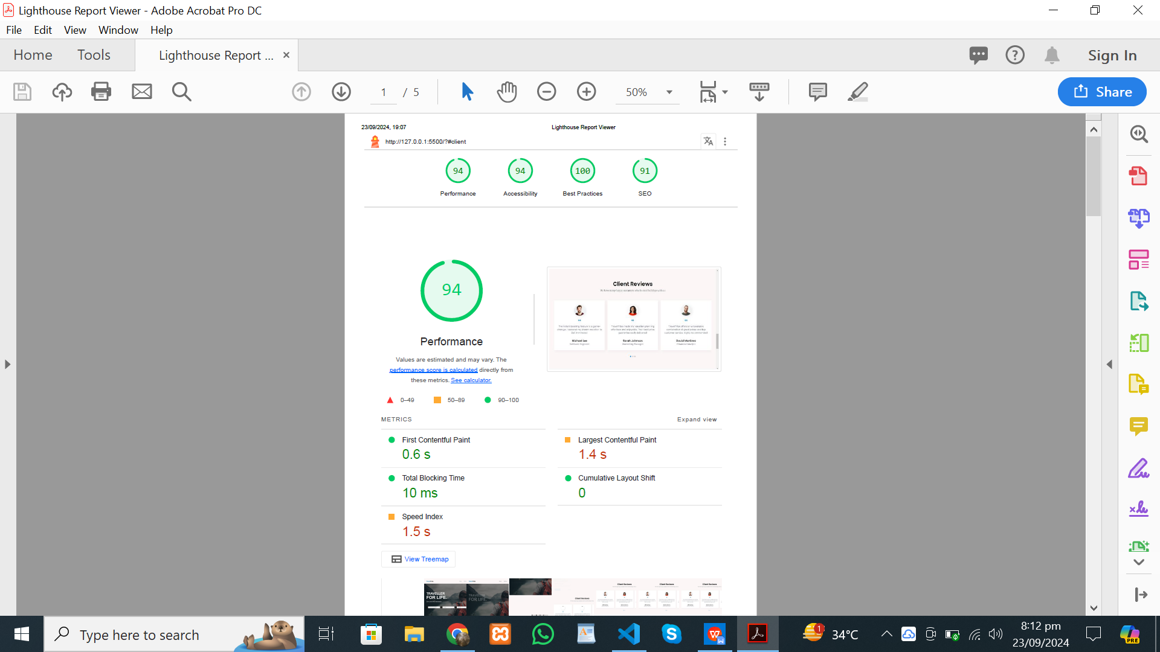

***5. Conclusion***

The optimizations significantly enhanced the website’s performance. By reducing HTTP requests, optimizing images, and lazy-loading resources, the website became more responsive, leading to faster load times and an improved user experience. These improvements are expected to lower bounce rates and increase user engagement.

This report summarizes the efforts and results of performance improvements made to TravelTribe. The steps taken have resulted in a faster, more accessible, and optimized website, improving the overall user experience.